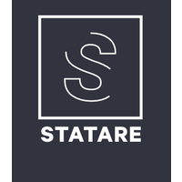



**Katsi Eleni**

**Mina Mariana**

**Agroti Louiza**

**Kouppi Maria**

LIST OF CUSTOMER’S COMMENTS

**The comments that we received from our customer are the following:**

* The company was requested to access our GitHub code.
* After we presented a constraint about the functionality of the buttons Clock in, Clock out, Break και Return from Break, that we implemented depending on the following scenario: an employee can not press Log out without pressing Clock out, they told us that this constraint is not necessary. Log out button should be independed from the button that employee had pressed.
* For the functionality Delete Employee and Edit Employee, they said that they prefer the selection of the employee who will be deleted or edited to be from a drop down list, instead of writing the username of the employee in a text box (because the manager has to remember all the usernames of the employees). This drop down list has to include the name, surname and username of the employee.
* About the Edit Profile functionality, it was requested to change the password display, that is, instead of a set number of asterisks, to display as many asterisks as the number of characters of the employee's password in the database.
* About the function of retrieving an employee's location, due to the VPN problems, it was decided with the company not to do this.